 **University of the Western Cape**

**Department of Computer Science**

**Private Bag X17, Bellville, 7535**

**CSC211- Data Structures and Algorithms II**

**ASSIGNMENT 1 (15 Marks). Student number: 3 8 5 1 7 2 7**

-----------------------------------------------------------------------------------------------------------------------------------------



**Figure 1: Binary trees**

1. Consider the trees in **Figure 1.** Determine (i) the root node (ii) leaf nodes (iii) the depth of the tree. [3]
2. A
3. G ; H; I ; L ; M ; K
4. 0

1. For **each node** in Figure 1, determine (i) the parent node, (ii) list of siblings and (iii) list of children. [7]

A : (i) none (ii) none (iii) B ; C H:(i) D (ii) G ; I ; J ; K (iii) NONE

B : (i) A (ii) C (iii) D ; E I: (i) E (ii) G;H;J;K (iii) NONE

C : (i) A (ii) B (iii) F J: (i) E (ii) G;H;I;K (iii) L ; M

D : (i) B (ii) E ; F (iii) G;H K:(i) F (ii) G;H;I;J (iii) NONE

E : (i) B (ii) D ; F (iii) I ; J L: (i) J (ii) M (iii) NONE

F : (i) C (ii) D ; E (iii) K M:(i) J (ii) L (iii) NONE

G :(i) D (ii) H ; J ; K (iii) NONE

1. For the tree shown in **Figure 2,** what would be the output of the code snippet below:

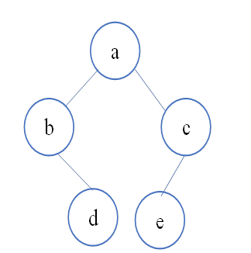

**Figure 2**

public static void printer (BinaryNode<node> n )

{

if (n != null)

{

System.out.println(t.getElement() + “\n”);

printer(t.getLeft());

System.out.println(t.getElement()+ “,”);

printer(t.getRight());

System.out.println(t.getElement()+ “,”);

}

}

[5]

a

b

b,

d

d,

a

e,

e

c,

c,